**Introduction to Software Project Management and Tools:**

Software Project Management involves the planning, coordination, execution, and monitoring of software projects to ensure they are completed on time, within budget, and according to specifications. It encompasses various processes, including project planning, resource allocation, risk management, and communication among team members and stakeholders. Effective project management relies on using appropriate tools and methodologies to streamline workflows, track progress, and facilitate collaboration. These tools can range from project management software like Jira, Asana, or Trello for task tracking and scheduling, to version control systems such as Git for managing code changes and collaboration among developers. Additionally, agile methodologies like Scrum or Kanban are often employed to iteratively deliver high-quality software while adapting to changing requirements and priorities. Overall, software project management and tools play a crucial role in ensuring the success and timely delivery of software projects.

**Software Project Analyzing Tools:**

Microsoft Project is a powerful project management software that offers various tools for analyzing software projects. Some of the key analyzing tools available in Microsoft Project include:

* **Gantt Chart:** The Gantt chart is one of the most essential tools in Microsoft Project for visualizing project schedules. It provides a graphical representation of tasks, their start and end dates, dependencies, and progress over time. Users can analyze project timelines, identify critical path tasks, and adjust schedules as needed.
* **Resource Management:** Microsoft Project allows users to analyze resource allocation and utilization using resource management tools. Users can view resource assignments, workload distribution, and resource availability to ensure optimal resource utilization throughout the project lifecycle.
* **Task Tracking and Progress Monitoring:** Users can track task progress and analyze project performance using task tracking tools in Microsoft Project. The software provides features for updating task statuses, tracking actual vs. planned progress, and generating progress reports to monitor project performance.
* **Baseline Comparison:** Microsoft Project enables users to establish project baselines and compare them against actual progress to analyze project variances. Users can assess deviations from the original plan, identify areas of concern, and take corrective actions to keep the project on track.
* **Reporting and Dashboards:** Microsoft Project offers reporting and dashboard tools to analyze project data and generate insights. Users can create customized reports, dashboards, and visualizations to communicate project status, track key performance indicators (KPIs), and make data-driven decisions.
* **Risk Management:** Microsoft Project includes tools for analyzing project risks and implementing risk management strategies. Users can identify potential risks, assess their impact and likelihood, prioritize risk responses, and track risk mitigation efforts to minimize project disruptions.
* **Cost Management:** Microsoft Project provides features for analyzing project costs and budgeting. Users can create cost estimates, track project expenses, compare actual costs to budgeted amounts, and analyze cost variances to ensure project profitability and financial control.
* **Integration with Other Microsoft Tools:** Microsoft Project integrates seamlessly with other Microsoft Office applications, such as Excel, Outlook, and SharePoint, enabling users to analyze project data and collaborate effectively across different platforms.

Project overview-

The "Make a Wish" ecommerce platform offers users the opportunity to purchase goods with a unique emphasis on customizable delivery scheduling. With this innovative feature, users can select their preferred delivery date and time, ensuring their purchases arrive precisely when needed. Whether planning for special occasions, coordinating deliveries around busy schedules, or simply ensuring timely receipt of products, "Make a Wish" empowers users with flexibility and convenience in managing their deliveries. This key feature distinguishes the platform, enhancing user experience and satisfaction, while also providing a competitive edge in the ecommerce market.

**Key features-**

Customizable delivery dates and times for product orders.

- Users can select preferred delivery schedules during the checkout process.

- Offers flexibility to accommodate busy schedules or special occasions.

- Ensures timely receipt of products according to user preferences.

- Enhances user convenience and satisfaction in the shopping experience.

- Sets the app apart from traditional ecommerce platforms by prioritizing personalized delivery options.

**Getting started with Microsoft project**

Launch Microsoft Project from your computer

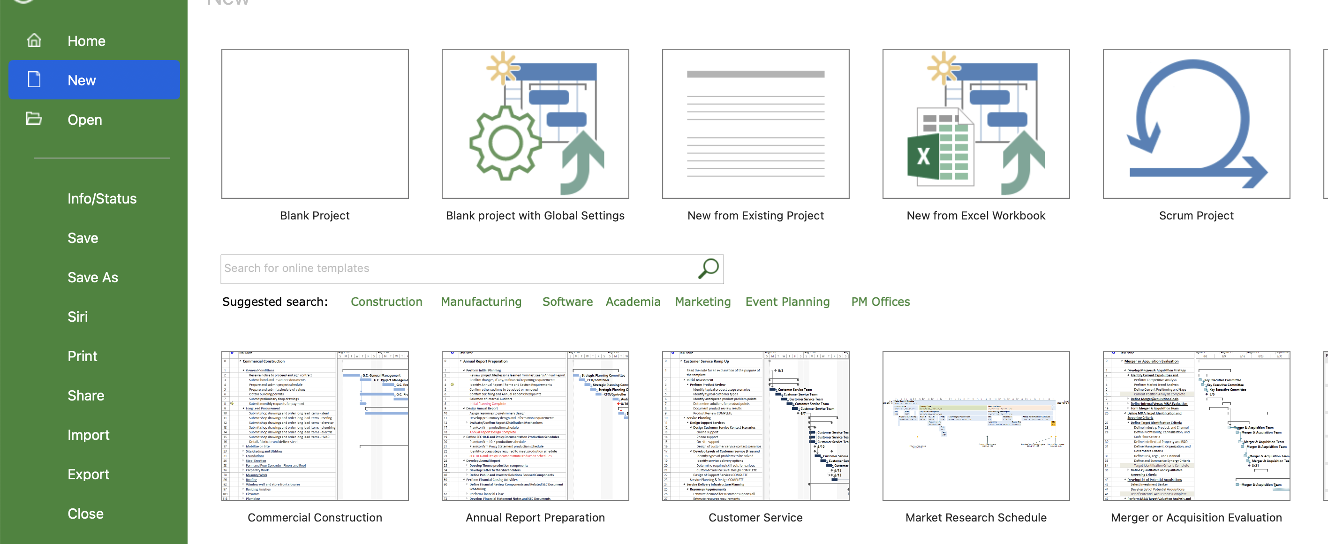

Create a new project

Open Microsoft Project and click on "Blank Project" to start a new project.

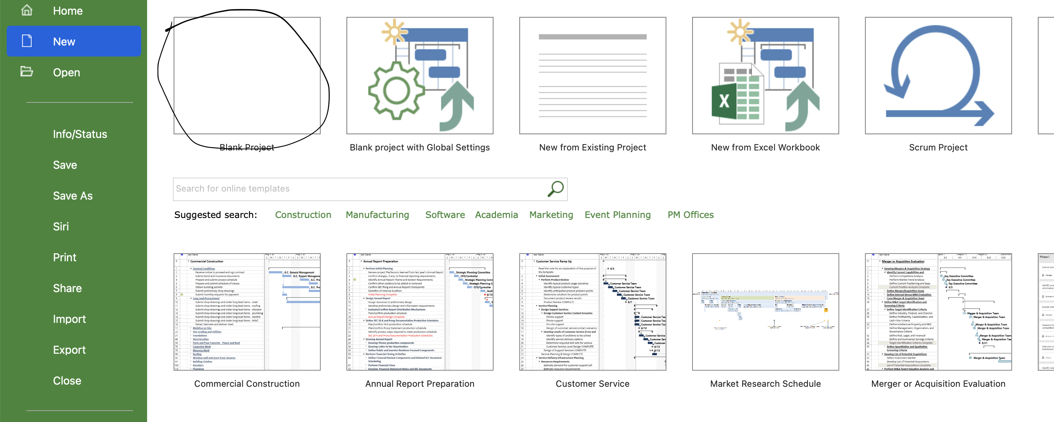

Navigating the Interface:

Familiarize yourself with the interface, which includes the ribbon, task pane, and Gantt Chart view.

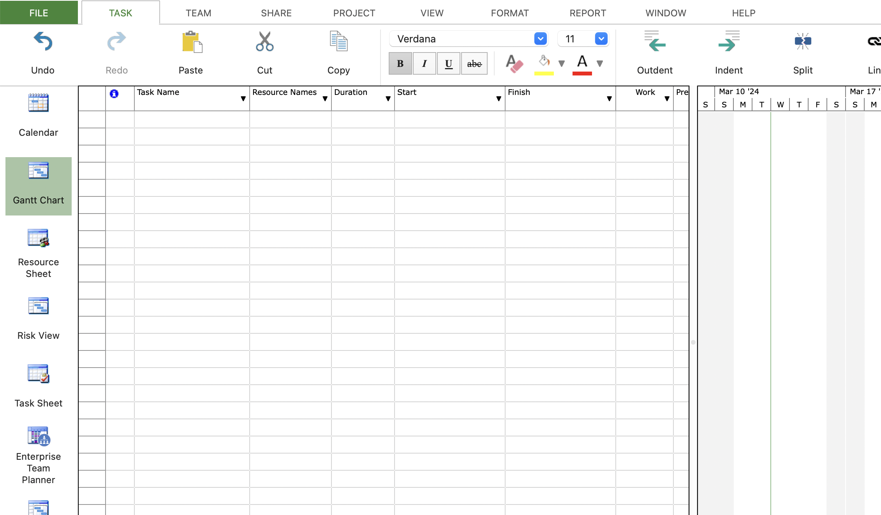

Adding Tasks:

Click on the "Task" tab in the ribbon.

Select "Task Name" to add tasks, and enter task names, durations, and start dates.

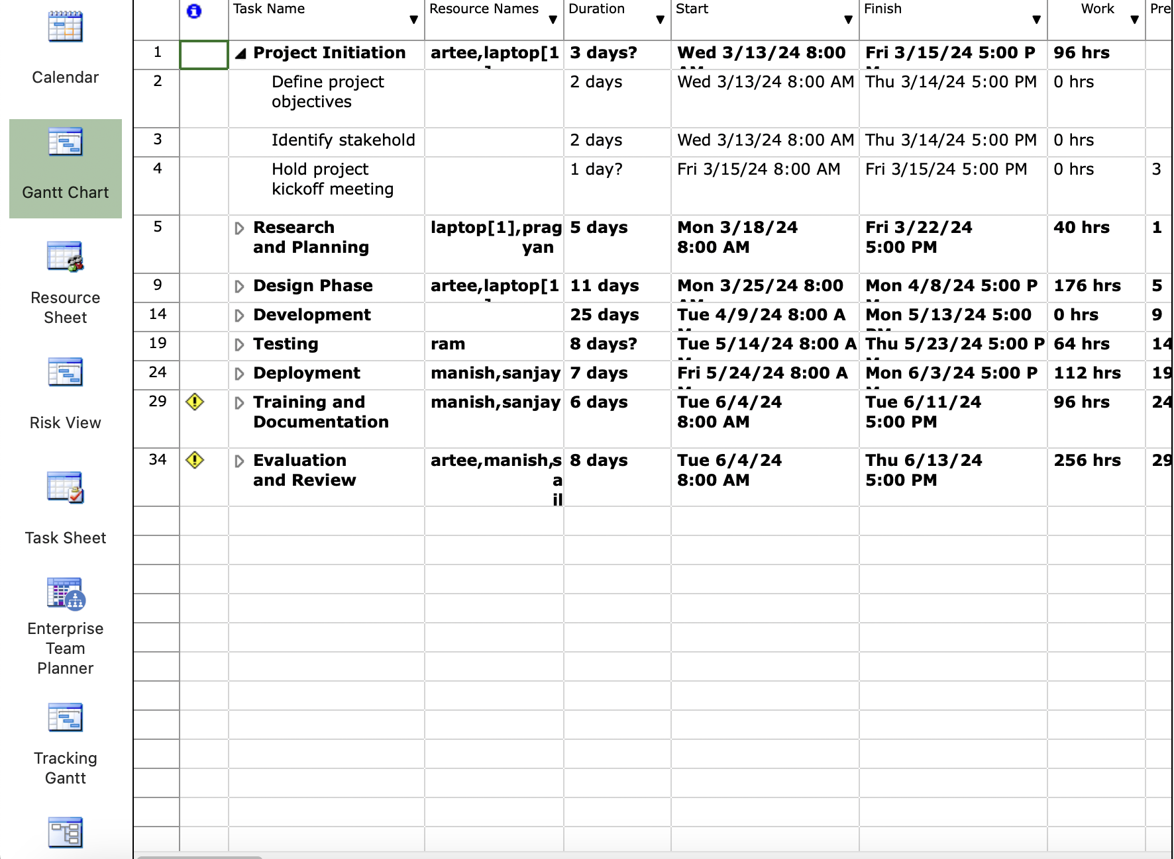



**Break down tasks into subphases by indenting them under parent tasks:**

Select the task you want to indent and click on the "Indent Task" button in the ribbon.

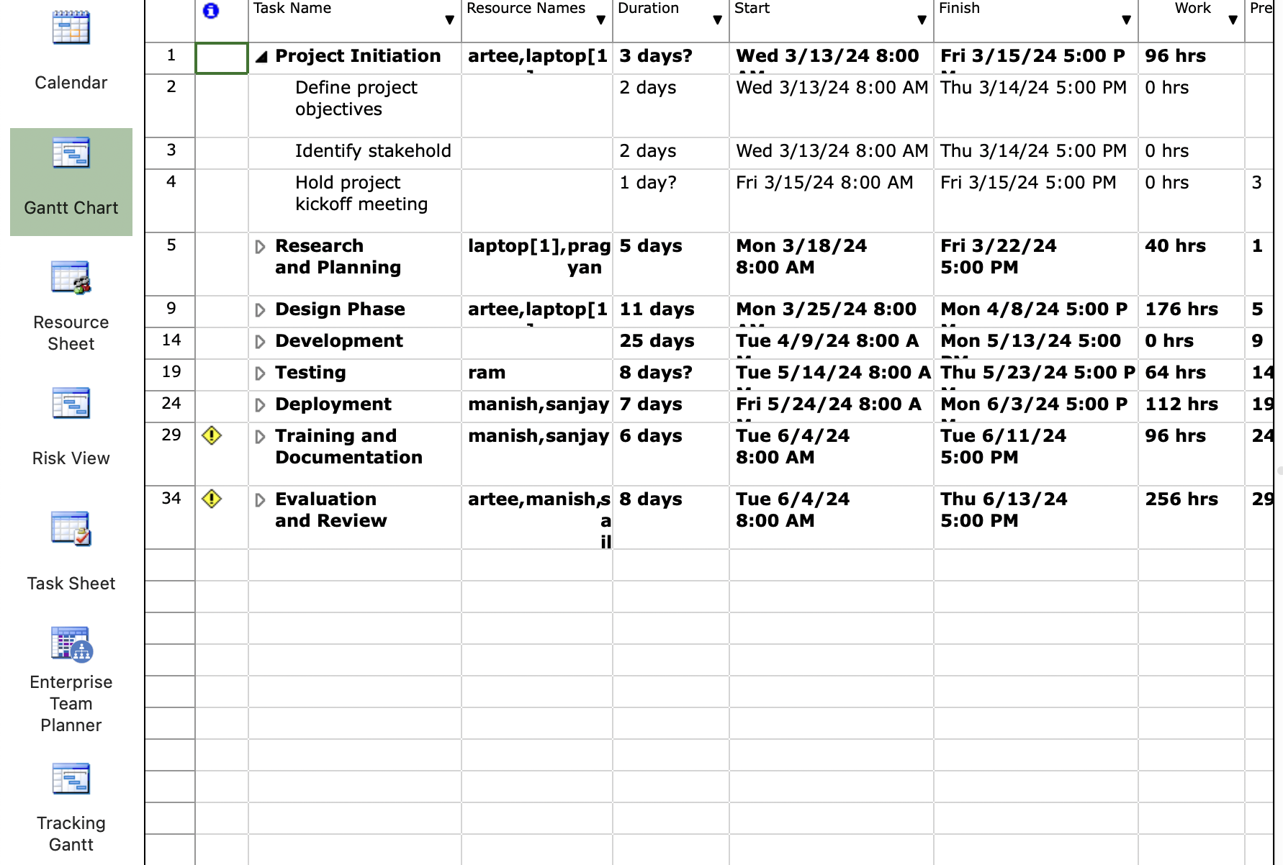



**Setting Dependencies:**

Define task dependencies by linking tasks together.

Select the predecessor task, go to the "Task" tab, and click on chain like icon "Link Tasks."

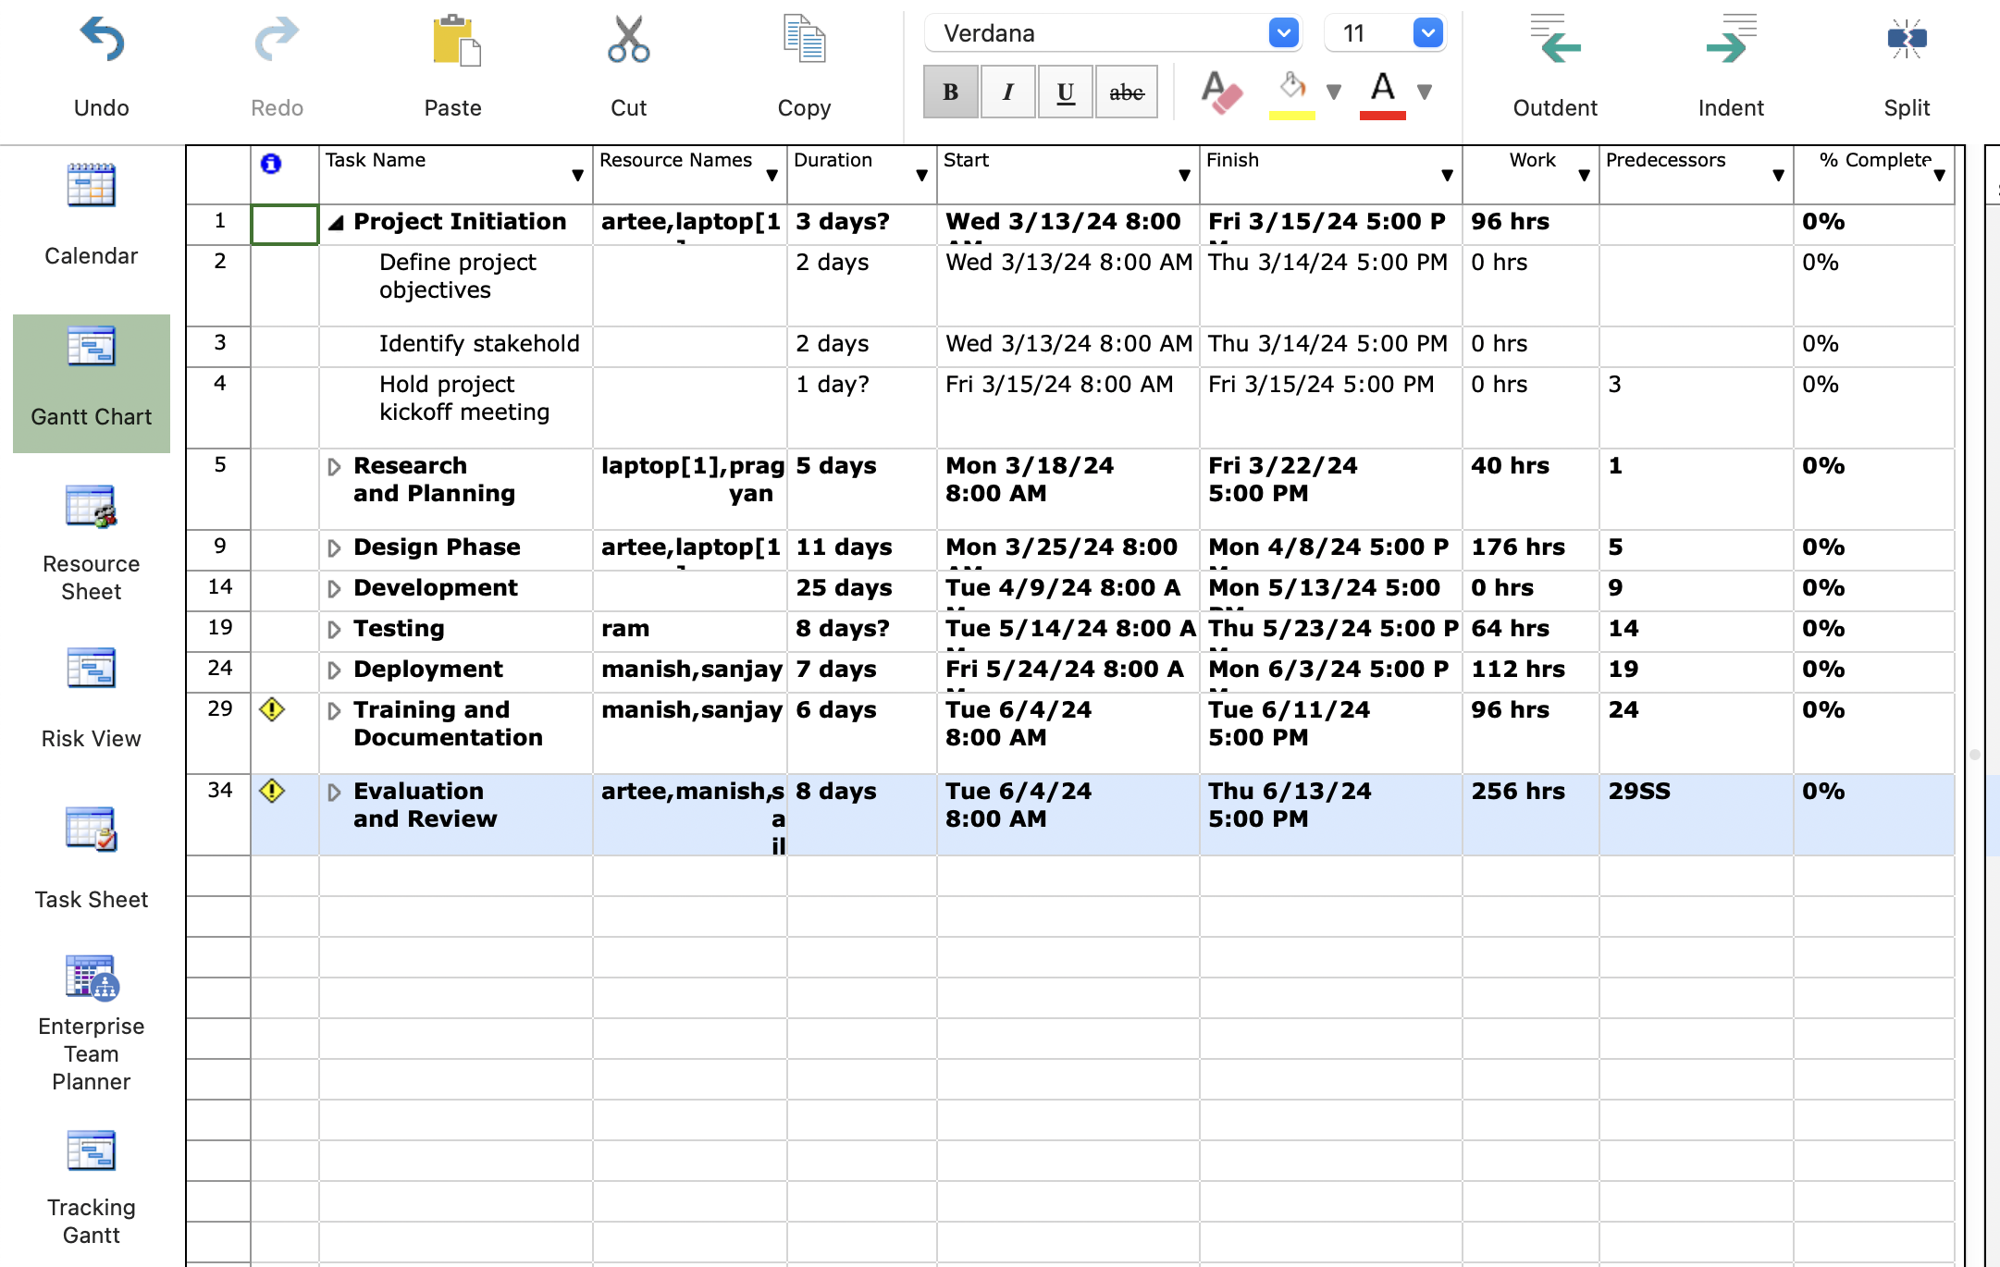



**• Assigning Resources:**

Allocate resources to tasks by assigning them from the resource pool.

First add resources to the "Resource Sheet".

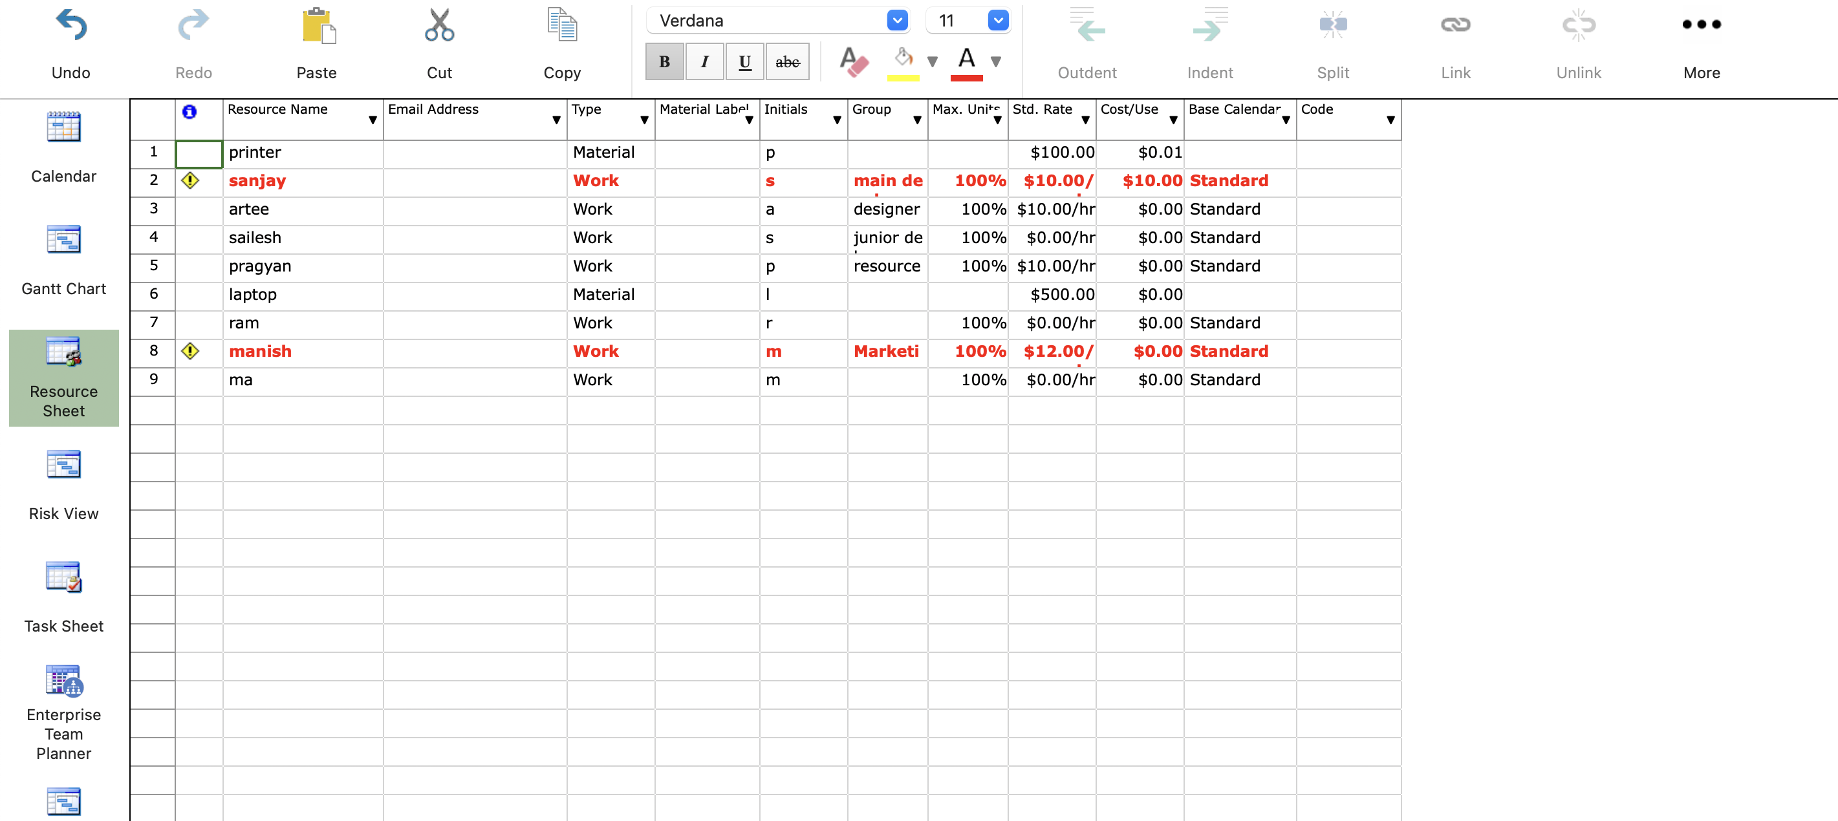

**click on task, navigate to the " Resource" tab, and select the resource from the dropdown.**

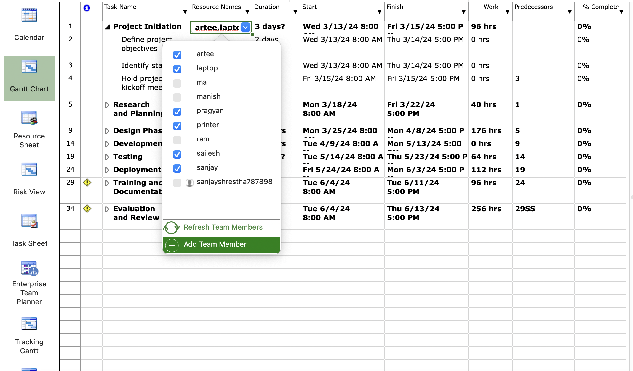

**Creating a network diagram**

Click on view

Select “Network Diagram”

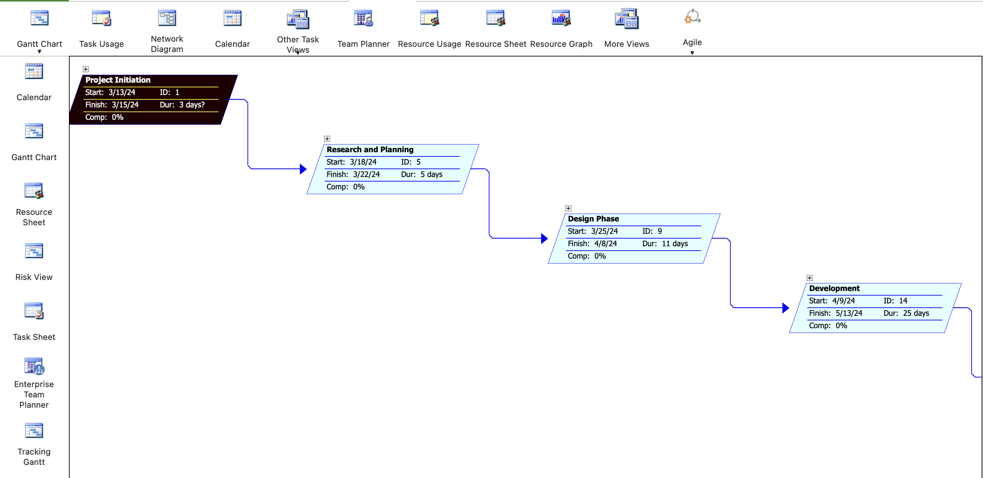

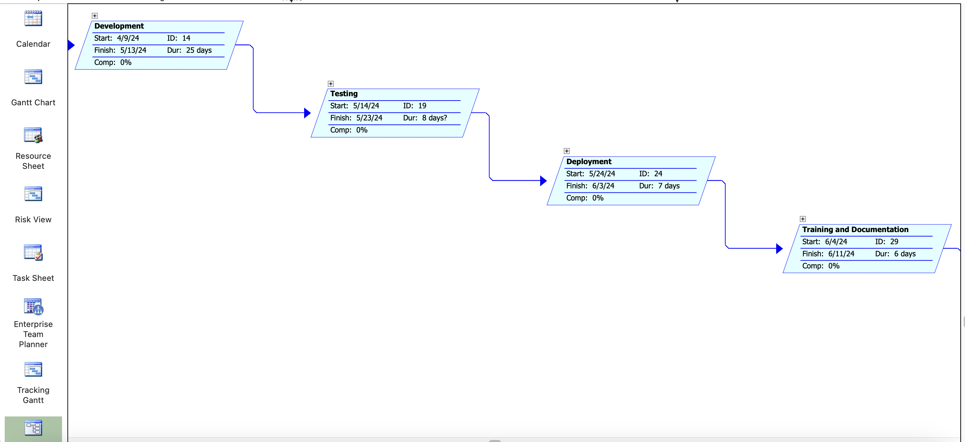

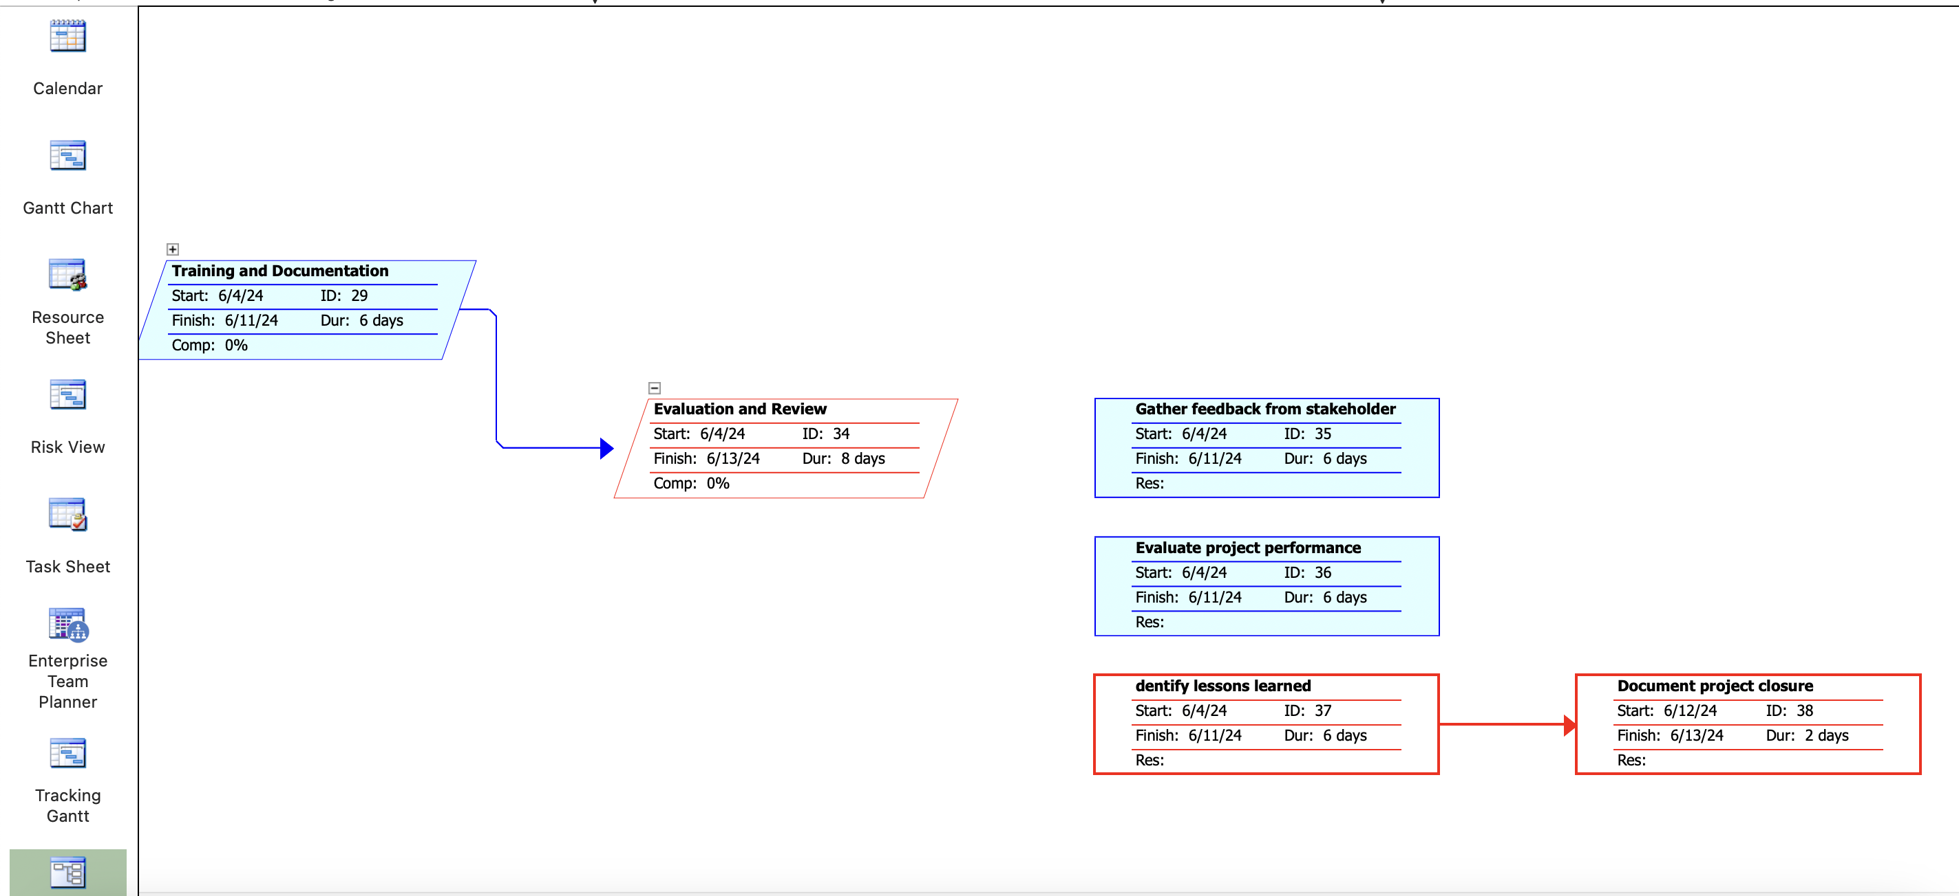

**Generating Reports:**

Utilize built-in reports or customize reports to monitor project performance.

Navigate to the "Report" tab in the ribbon to access reporting options.

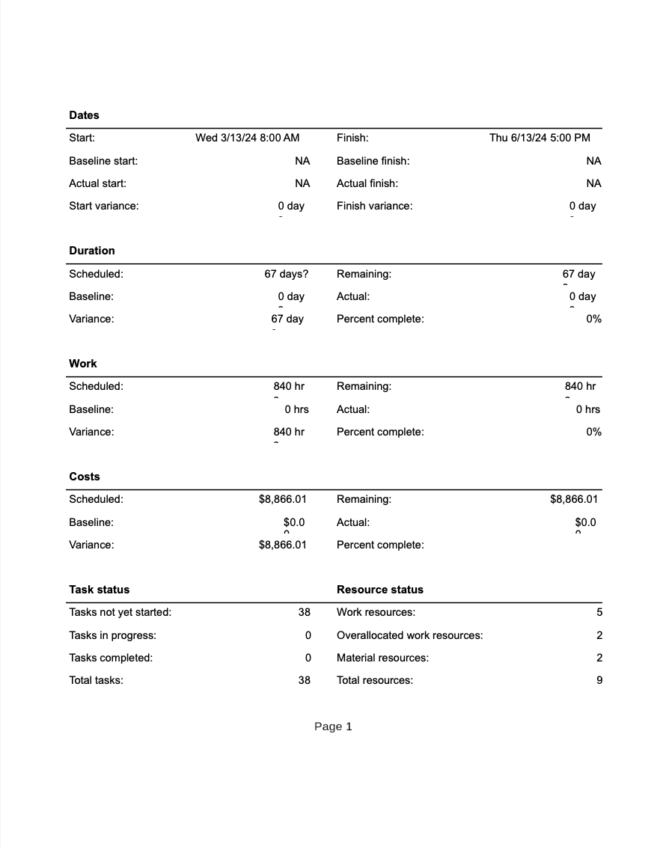

**Gantt chart**

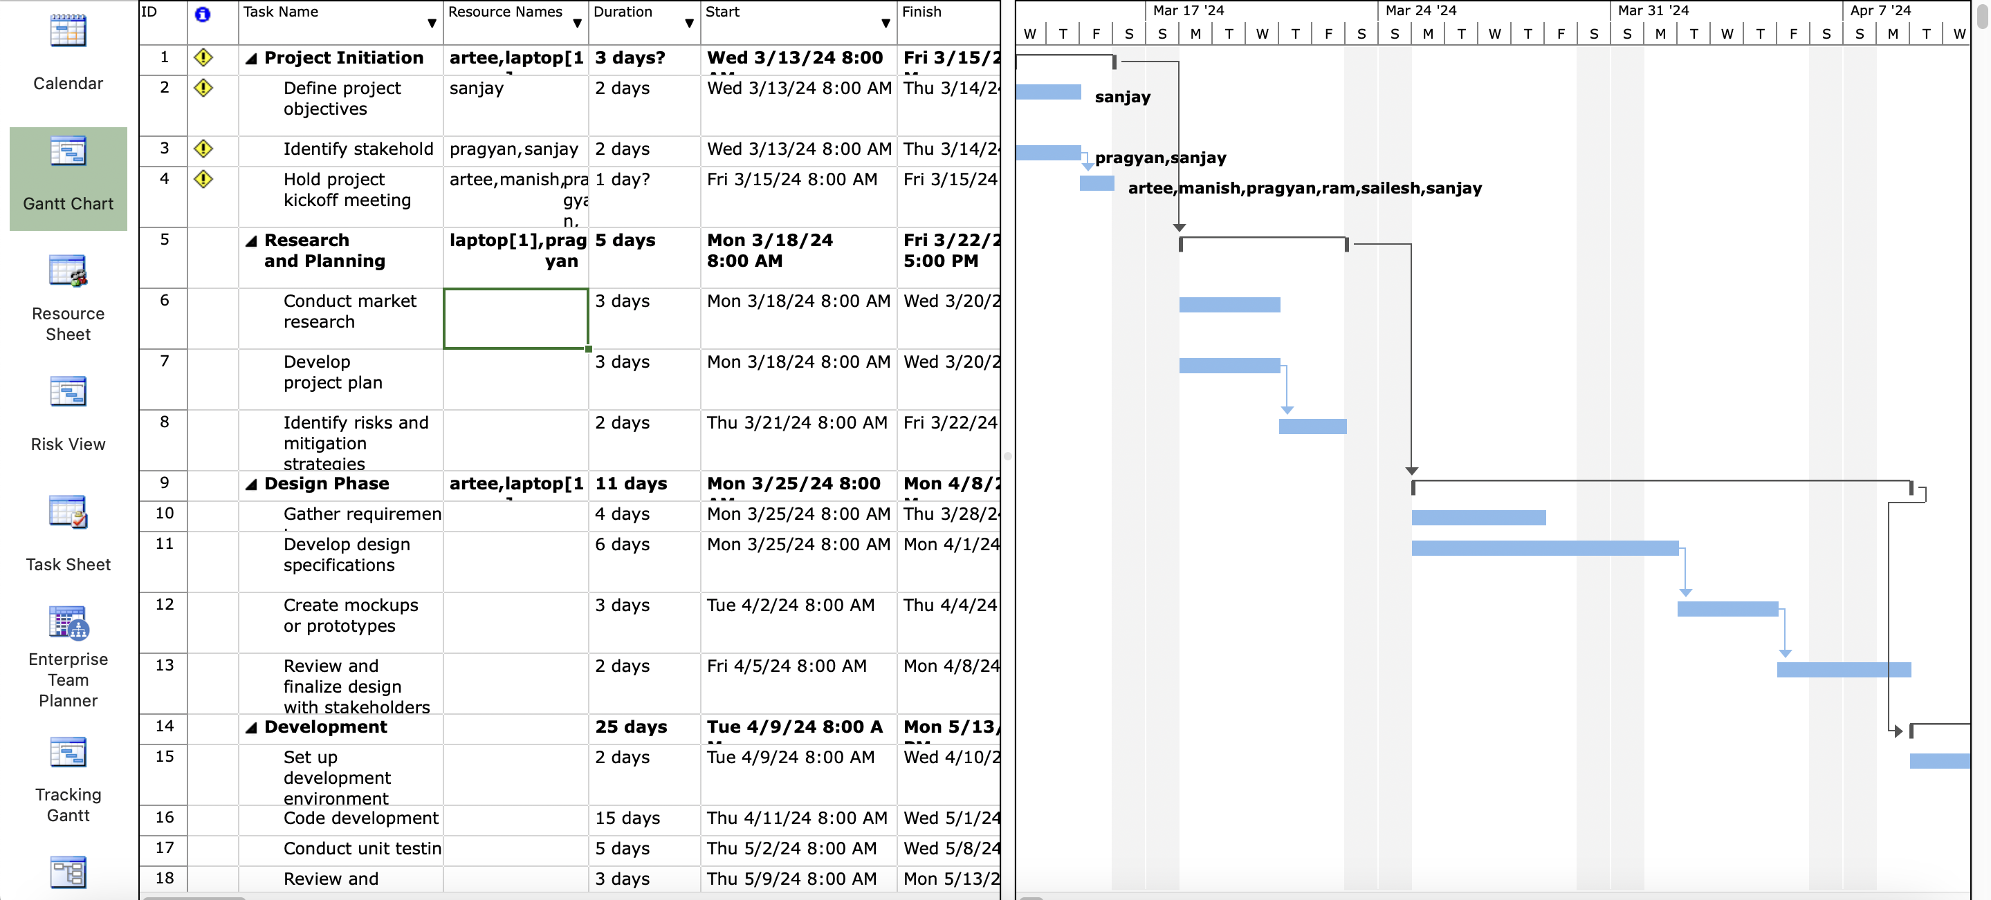

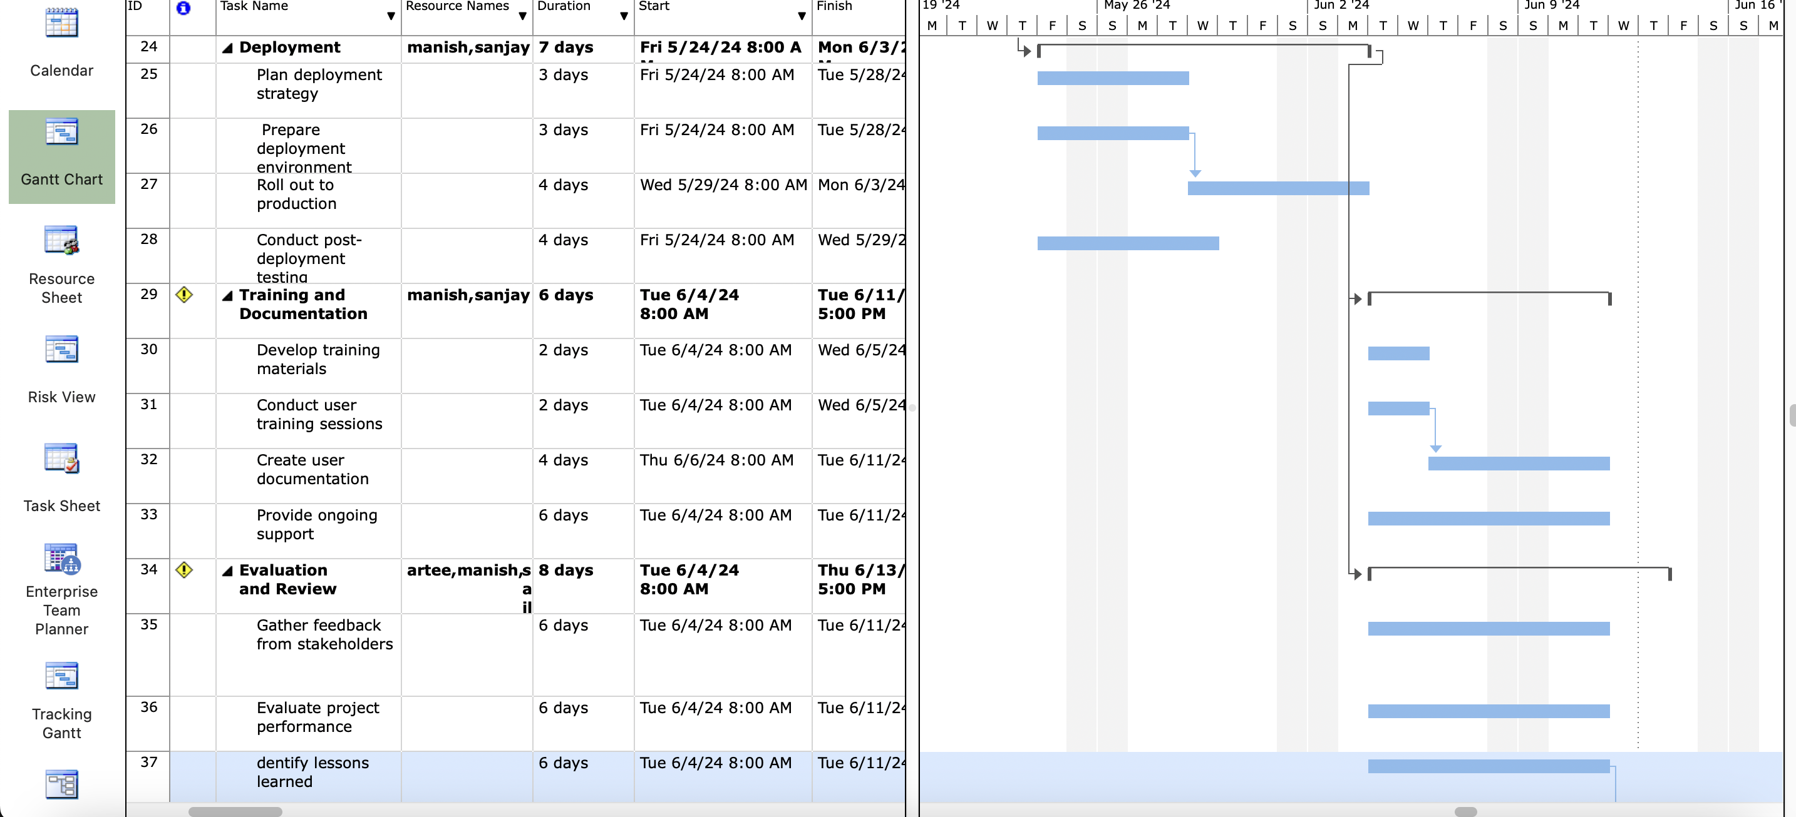

**Calander**

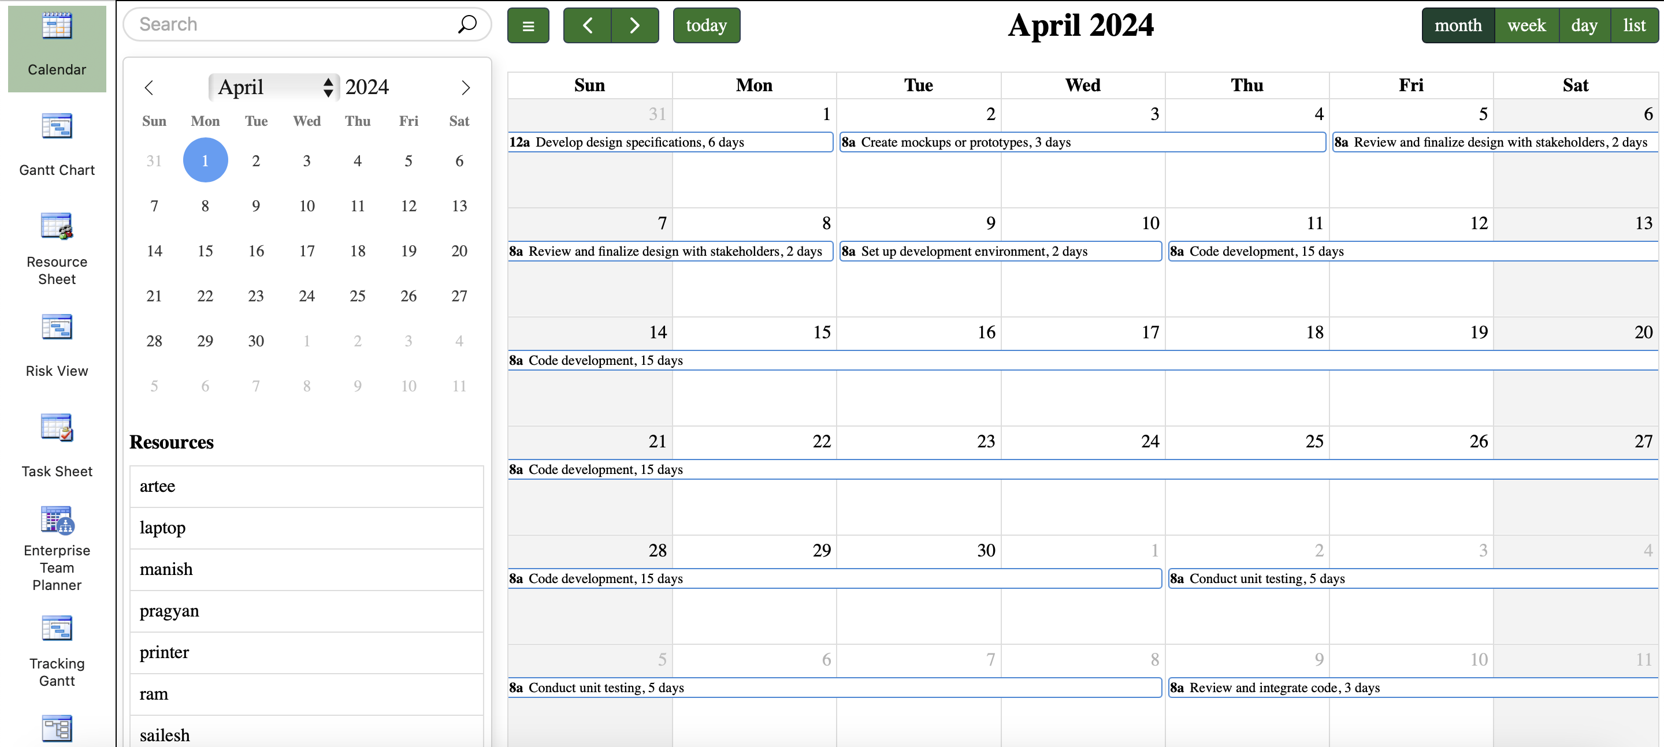

**Resource graph**

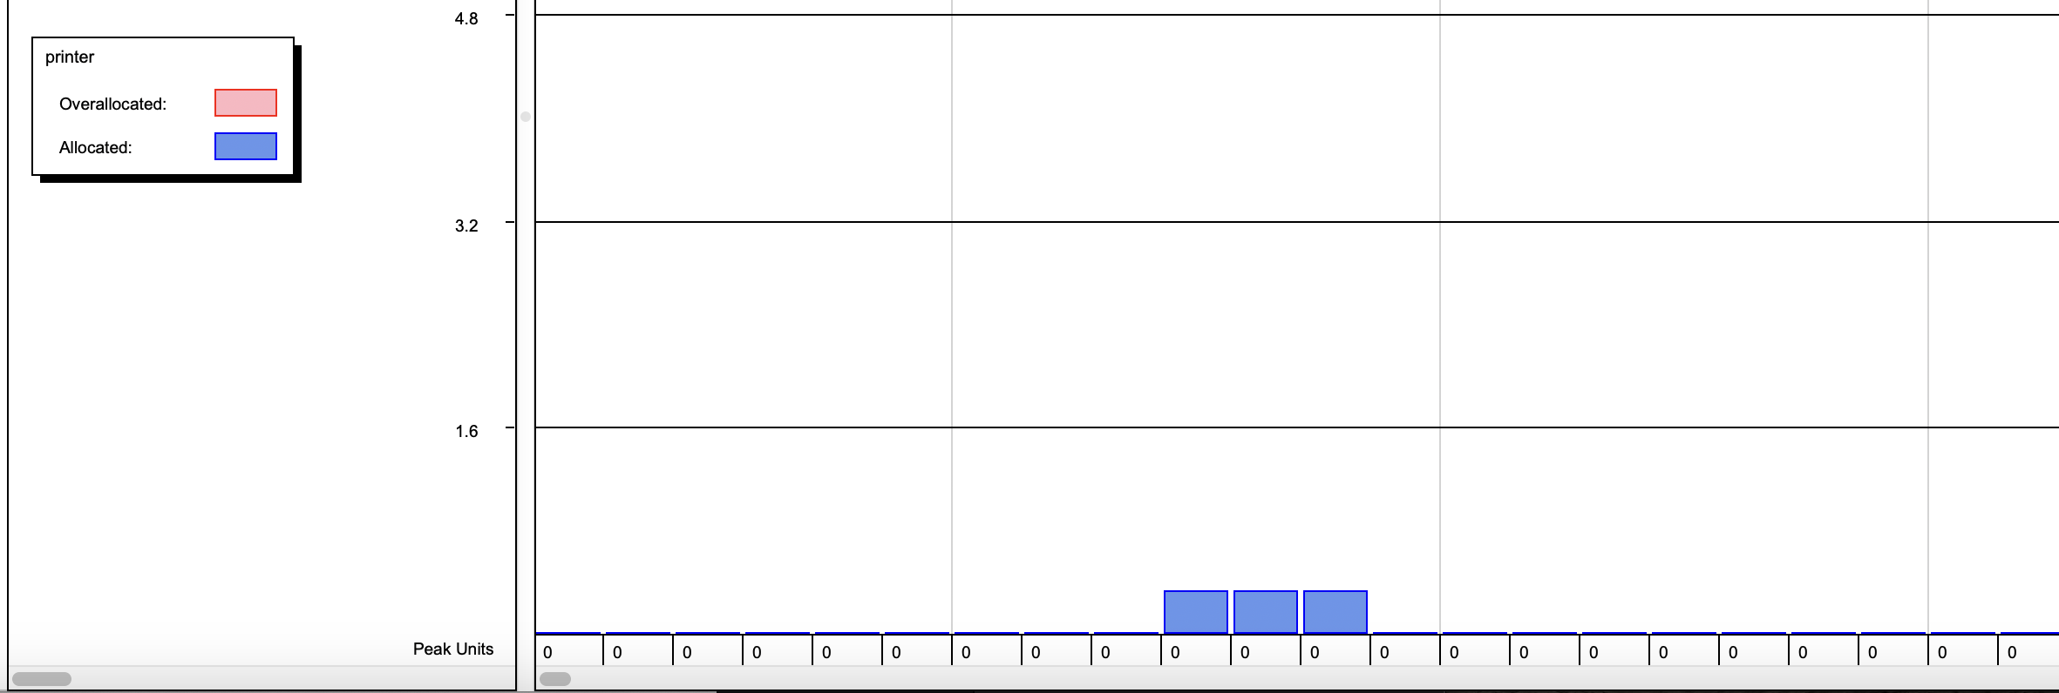

**Team planner**

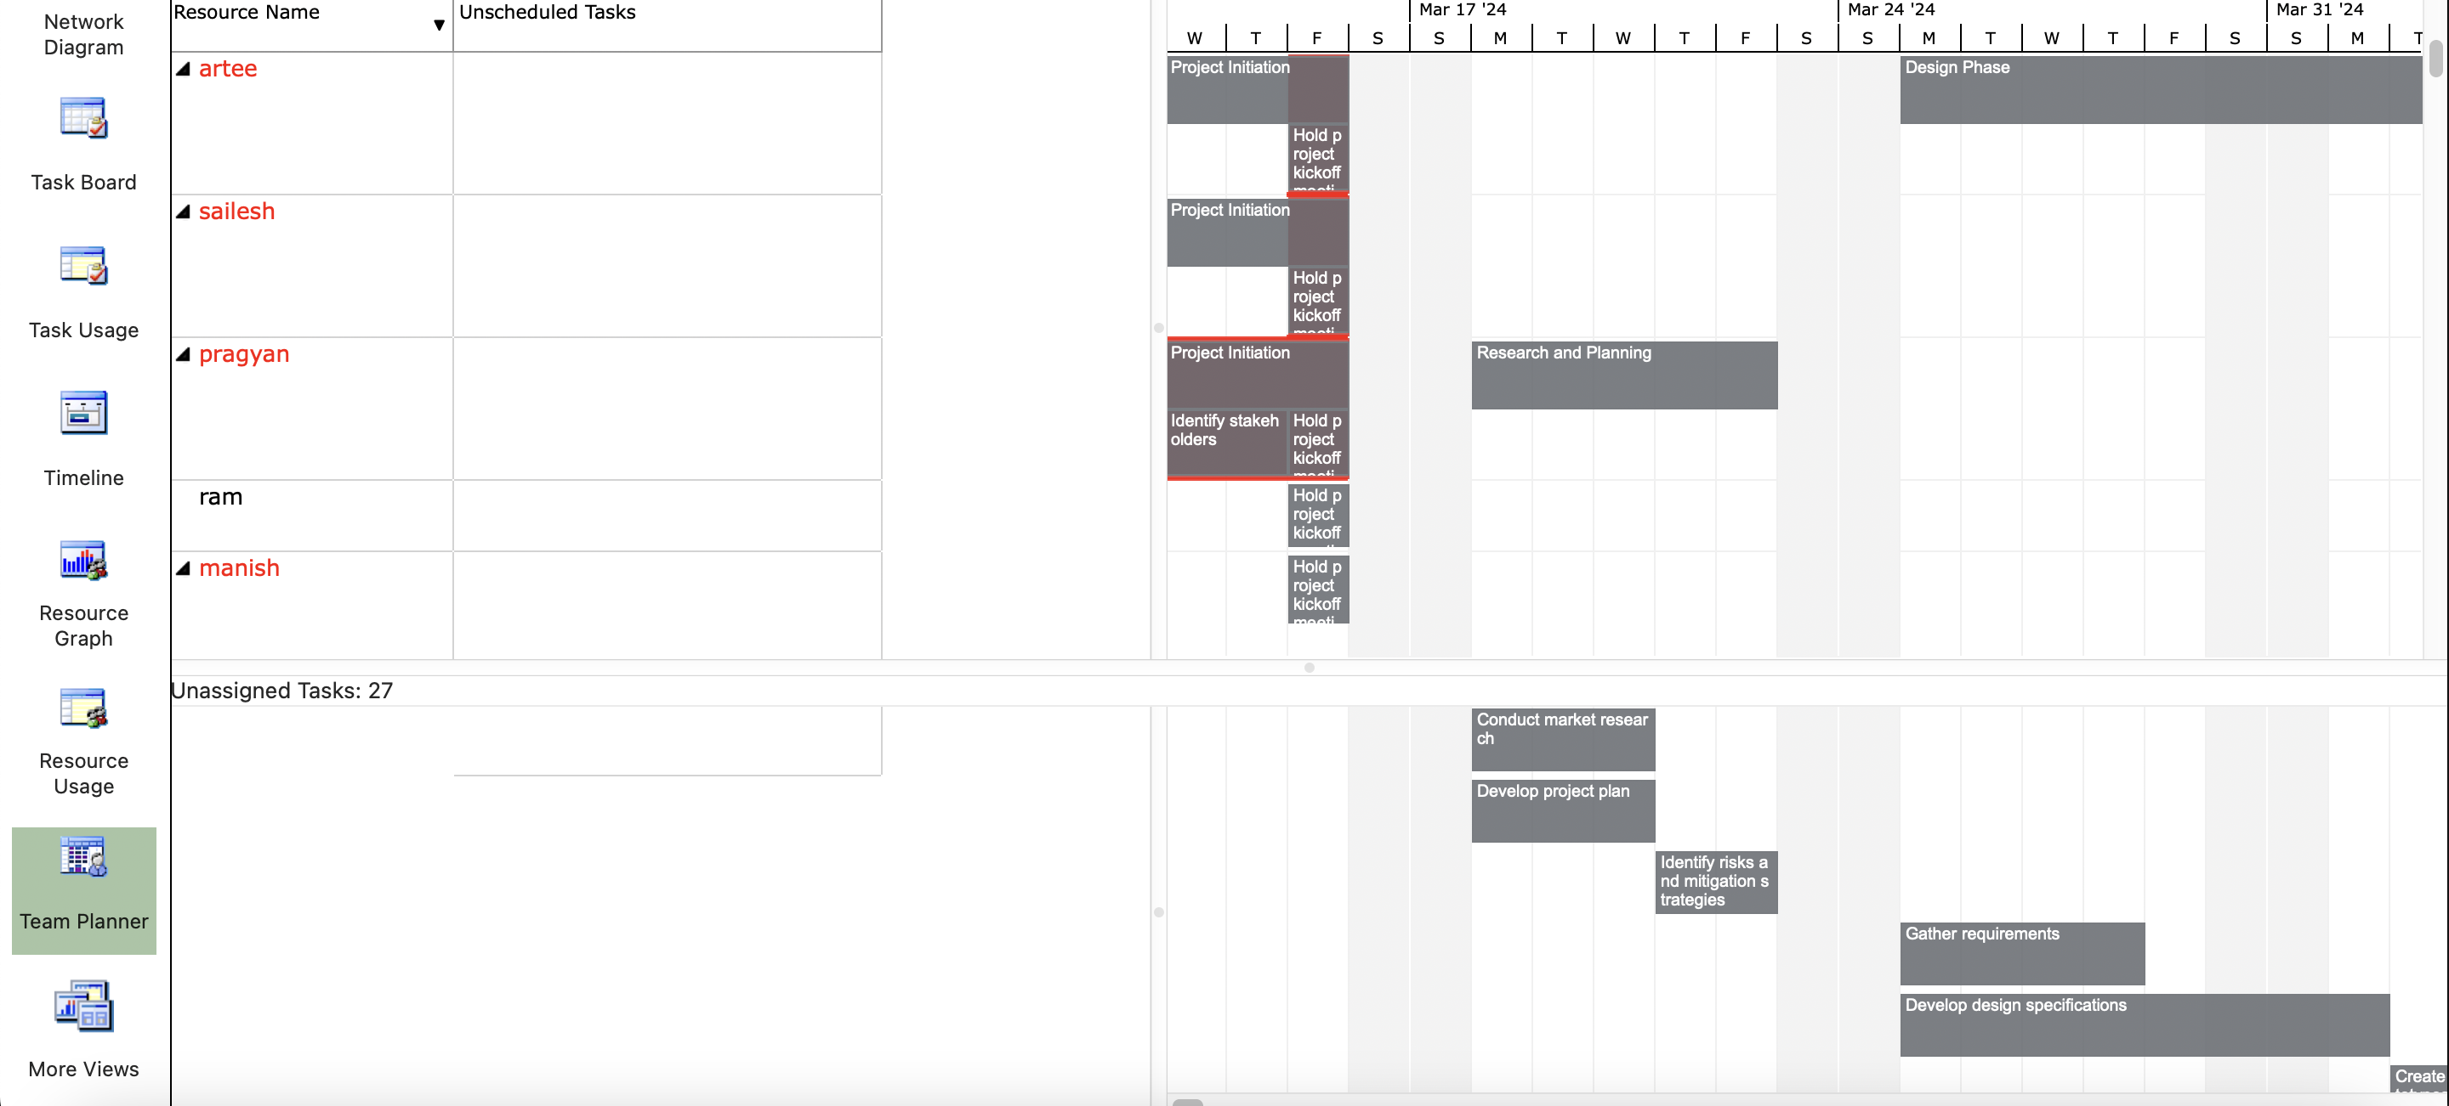

**Resource usage**

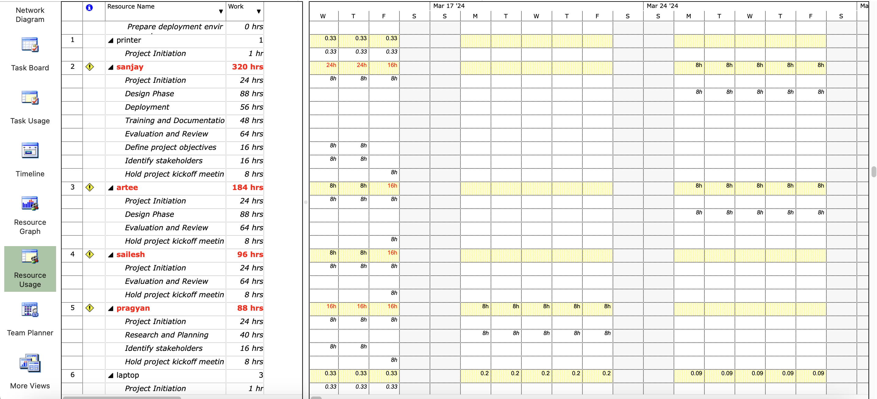

**Task sheet**

